**验证拓扑**

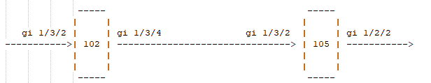

**102配置：**

**1、设备命令配置**

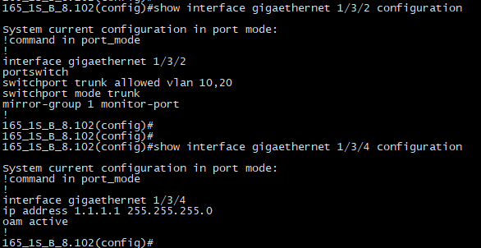

网络口1/3/4的mac地址：

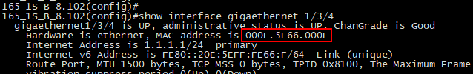

**2、SDK命令配置**

port 0x0003 phy-if enable

l3if create ifid 2 type vlan-if vlan 10

l3if router-mac 000E.5E66.0001

overlay-tunnel vn-id 1000 fid 4096

port 0x0001 scl-key-type scl-id 0 direction ingress type ipsg-port-mac

vlan mapping add port 0x0001 macsa 0000.aaaa.1111 mapping-to vn-id 1000 logic-port 500

nexthop add ip-tunnel 10 dsnh-offset 10 fwd mac 000E.5E69.000D routed-port 0x0003 type tunnel-v4 vxlan strip-vlan ipsa 1.1.1.1 ipda 1.1.1.2 dscp 0 dscp-select 0 ttl 10 map-ttl logic-dest-port 1000

l2 fdb add mac 0000.aaaa.0000 fid 4096 nexthop 10 static

port 0x0003 scl-key-type scl-id 0 direction ingress type vxlan

overlay-tunnel add vxlan src-vnid 1000 ipda 1.1.1.1 ipsa 1.1.1.2 dst-vnid 1000 tunnel-src-port 1000

nexthop add egs-vlan-edit 20 port 0x0001 cvlan-edit-type 1 svlan-edit-type 3 output-cvid 1 output-svid 10 svlan-valid logic-dest-port 500

l2 fdb add mac 0000.aaaa.1111 fid 4096 nexthop 20 static

l2 fdb add vlan-default-entry fid 4096 group 4096 use-logic-port

l2 fdb logic-nhid logic-port 1000 nexthop 10

l2 fdb logic-nhid logic-port 500 nexthop 20

l2 fdb vlan-default-entry fid 4096 add nexthop 10

l2 fdb vlan-default-entry fid 4096 add nexthop 20

**105配置：**

**1、设备命令配置**

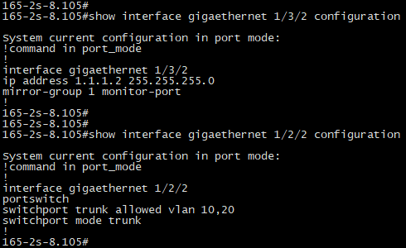

网络口1/3/2的mac地址：

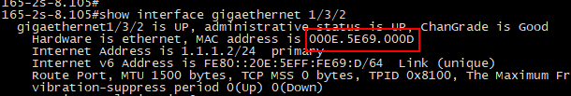

**2、SDK命令配置**

port 0x0001 phy-if enable

l3if create ifid 2 type vlan-if vlan 10

l3if router-mac 000E.5E69.0001

overlay-tunnel vn-id 1000 fid 4096

port 49 scl-key-type scl-id 0 direction ingress type ipsg-port-mac

vlan mapping add port 49 macsa 0000.aaaa.0000 mapping-to vn-id 1000 logic-port 500

nexthop add ip-tunnel 10 dsnh-offset 10 fwd mac 000E.5E66.000F routed-port 0x0001 type tunnel-v4 vxlan strip-vlan ipsa 1.1.1.2 ipda 1.1.1.1 dscp 0 dscp-select 0 ttl 10 map-ttl logic-dest-port 1000

l2 fdb add mac 0000.aaaa.1111 fid 4096 nexthop 10 static

port 0x0001 scl-key-type scl-id 0 direction ingress type vxlan

overlay-tunnel add vxlan src-vnid 1000 ipda 1.1.1.2 ipsa 1.1.1.1 dst-vnid 1000 tunnel-src-port 1000

nexthop add egs-vlan-edit 20 port 49 cvlan-edit-type 1 svlan-edit-type 3 output-cvid 1 output-svid 10 svlan-valid logic-dest-port 500

l2 fdb add mac 0000.aaaa.0000 fid 4096 nexthop 20 static

l2 fdb add vlan-default-entry fid 4096 group 4096 use-logic-port

l2 fdb logic-nhid logic-port 1000 nexthop 10

l2 fdb logic-nhid logic-port 500 nexthop 20

l2 fdb vlan-default-entry fid 4096 add nexthop 10

l2 fdb vlan-default-entry fid 4096 add nexthop 20

**验证结果**

仪表接102设备的1/3/2口打流，在105设备的1/2/2口抓发出的报文，验证结果显示102设备能正确封装vxlan报头，105收到报文终结能正常解封装vxlan报文，从二层接口1/2/2转发出去。

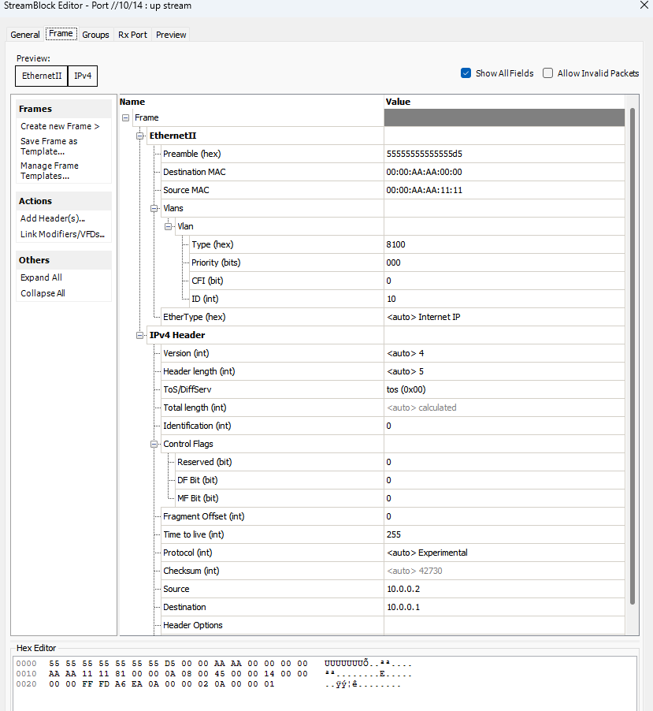

**1、102设备1/3/4口发出报文：**

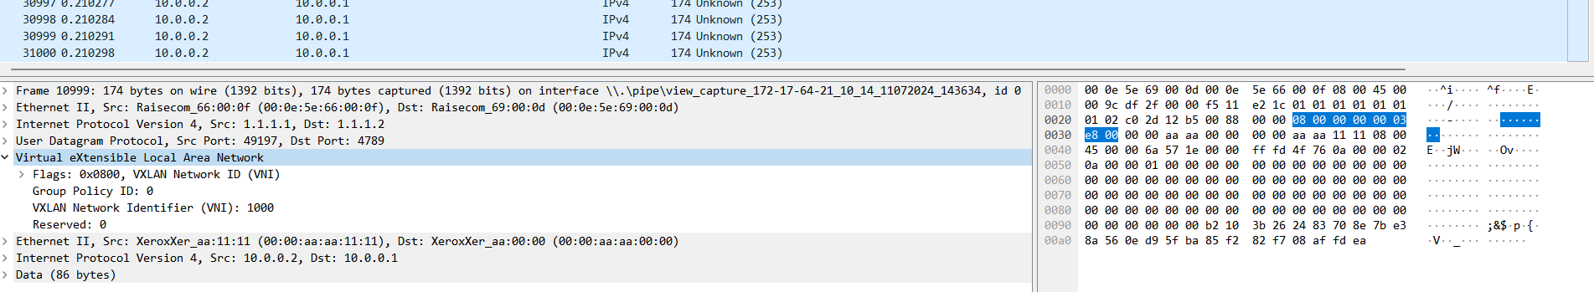

**2、105设备1/2/2口发出的报文：**

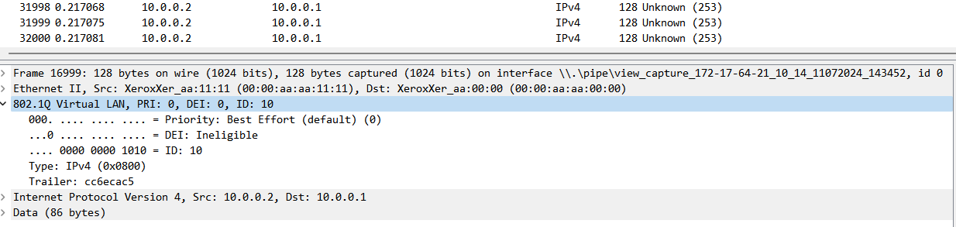

**3、105设备上SDK抓取芯片流水**

